Submitted by RAVI KRISHNAN

job portal management system

# TABLE OF CONTENTS

1. INTRODUCTION....................................................................................1

1.1 PURPOSE...............................................................................................2

1.2 SCOPE......................................................................................................2

1.3 OBJECTIVES.........................................................................................3

2. FUNCTIONAL REQUIREMENTS.....................................................3

2.1 PRIMARY ACTORS OF THE SYSTEM.....................................3

2.2 USE CASE DIAGRAMS.....................................................................4

2.2.1 ADMIN.................................................................................................4

2.2.2 JOB PROVIDER................................................................................5

2.2.3 JOB SEEKER......................................................................................5

2.3 USER STORIES........................................................................................6

2.3.1 ADMIN....................................................................................................7

2.3.2 JOB PROVIDER...................................................................................8

2.3.3 JOB SEEKER.........................................................................................8

2.4 BUSINESS PROCESS DIAGRAM......................................................9

3. NON-FUNCTIONAL REQUIREMENTS..............................................10

4. TECHNICAL REQUIREMENTS...............................................................11

5.CONCLUSION……………………………………………………...11

**1.Introduction**

1.1 Purpose

This document outlines the software requirements for the development of a Job Portal System. It serves as a guide for everyone involved in the project—from developers and testers to project managers and future users. The goal is to ensure there’s a shared understanding of what the system should do, how it should behave, and what constraints or expectations are involved. It includes detailed functional and non-functional requirements, use case descriptions, and other technical details that will shape how the system is designed and built.

1.2 Scope

The Job Portal System is a web-based platform created to bridge the gap between people looking for jobs and organizations offering them. It allows job seekers to browse listings, apply to positions, and manage their profiles. On the other hand, employers can post job openings, review applications, and reach out to potential candidates. There’s also an admin interface, which helps keep the system running smoothly by managing users and content.

This platform is intended to be straightforward and user-friendly, catering to the needs of three main groups: Job Seekers who are trying to find employment opportunities. Job Providers or employers who are looking to hire. System Administrators who handle the backend and oversee platform operations.

1.3 Objectives

The Job Portal System aims to simplify the hiring process for both employers and job seekers by offering an organized, digital solution. Here are the main objectives, It makes job searching and application processes more efficient and less time-consuming. Provide employers with an easy way to post jobs and manage candidate responses. Give job seekers the ability to maintain a professional profile and apply for suitable positions easily. Offer filtering and search tools to match candidates with the right jobs quickly. Maintain a secure and reliable platform where user data is protected. Equip administrators with tools to monitor and manage the overall health and activity of the system. Build the system in a way that it can grow and improve over time without needing major overhaul

2.FUNCTIONAL REQUIREMENTS

**2.1 Primary Actors of the System**

The Job Portal System is designed to serve the needs of three primary user groups, each with distinct responsibilities and interactions within the system. Clearly identifying these actors ensures the development of targeted functionalities that address real-world use cases and streamline the recruitment process.

**2.1.1 Admin**

The Admin is the system’s overseer, responsible for maintaining the integrity, security, and overall functionality of the platform. Admins have privileged access that allows them to manage user accounts (job providers and job seekers), monitor system activity, approve or remove job listings, and respond to misuse or policy violations. Their role is crucial to ensure a trustworthy and balanced environment where both employers and job seekers can interact securely and efficiently.

**2.1.2 Job Provider**

Job Providers represent companies, HR personnel, or individuals authorized to post employment opportunities. Their primary function is to create, update, and manage job listings. They also review applications, contact potential candidates, and manage the recruitment pipeline. The system supports job providers in organizing applications, setting interview schedules, and maintaining communication with applicants, thereby streamlining the hiring process.

**2.1.3 Job Seeker**

Job Seekers are individuals actively searching for employment opportunities. Their role involves creating and managing a personal profile, uploading resumes, browsing available jobs, and submitting applications. The system assists job seekers by offering advanced job search features, application tracking, personalized job recommendations, and communication tools. Empowering job seekers with a user-friendly interface is key to enhancing their experience and success in finding suitable employment.

**2.2 USE CASE DIAGRAMS**

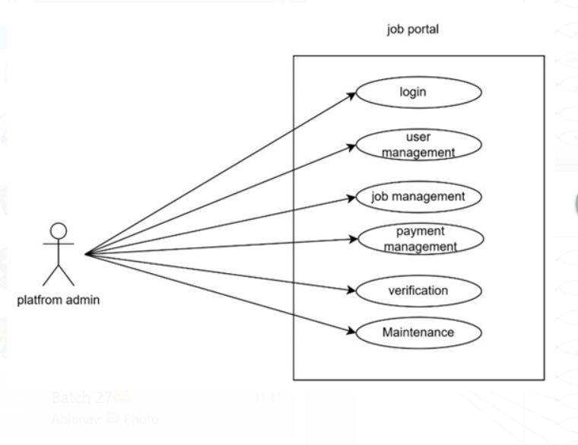**2.2.1 ADMIN**

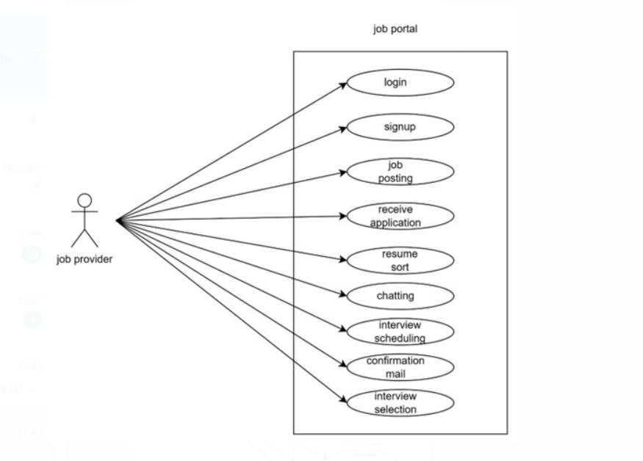**2.2. 2 job provider**

**2.2.3 job seeker**

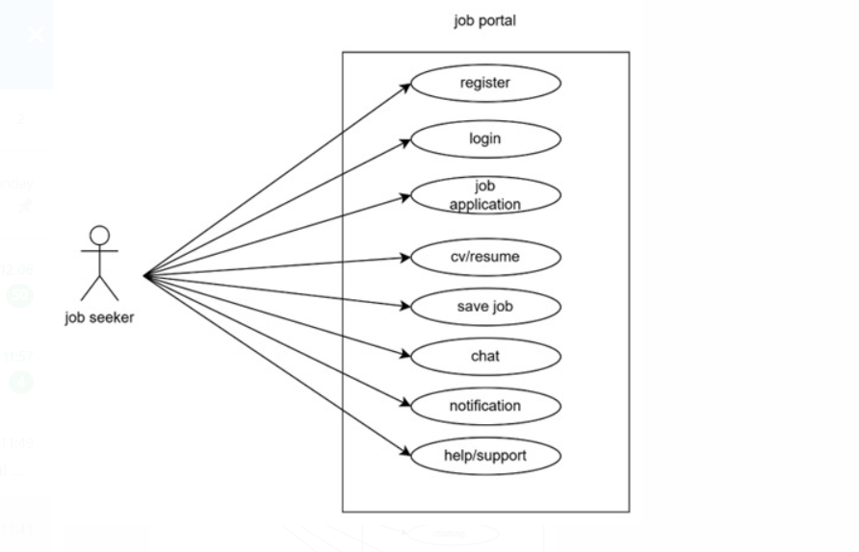

**2.3 USER STORIES**

|  |  |  |
| --- | --- | --- |
| **AS A [type of user]** | **I NEED TO [do some task]** | **SO THAT I CAN [get some result]** |
| **Platform Admin** | **Login to the portal by entering details** | **Ensure a authorized access to the platform, different user have different login details** |
| **Platform Admin** | **Maintain user accounts and permission** | **Allows job seekers and employers to create profiles, providing essential details, job seekers and job providers can track application status** |
| **Platform Admin** | **Maintain payments and subscription plans** | **Allows users to unlock premium levels, users can upgrade or cancel subscription, improves the growth** |
| **Platform Admin** | **Job management and details** | **Ensure accurate, up-to-date listings for job seekers, help users to get the job opportunities easily** |
| **Platform Admin** | **Perform Regular updates and maintenance** | **Keep the platform running smoothly with out any errors or bugs** |

**2.3.1 ADMIN**

|  |  |  |
| --- | --- | --- |
| AS A [type of user] | I NEED TO [ do some task] | SO THAT I CAN [get some result] |
| Job provider | Login | Register and job details |
| Job provider | Finding candidates | Searching people who have the right skill and experience |
| Job provider | Posting job advertisements | Sharing with website, newspapers, or social media. |
| Job provider | Receive application | Checking resumes and application to shortlist |
| Job provider | Coordinating interviews | Scheduling meeting with candidates. |
| Job provider | Conformation mail | Helping candidates improve if they don’t get selected or select |

**2.3.2 job provider**

|  |  |  |
| --- | --- | --- |
| AS a (type of user) | I need to(do some task) | So that I can(get some result) |
| Job seeker | Login into the application by entering personal details | access the platform to find oppurtunities |
| Job seeker | upload my CV/Resume | Showcase my skills and provide details to the job provider |
| Job seeker | Search and apply for the job | Be eligible in the eyes of the employer in order to obtain the desired position |
| Job seeker | Save jobs | I can apply later or track interesting jobs |
| Job seeker | Message and Get notifications | I can keep contact with the employers |
| Job seeker | Access help/support | I can resolve any issues with the account |

**2.3.3 job seeker**

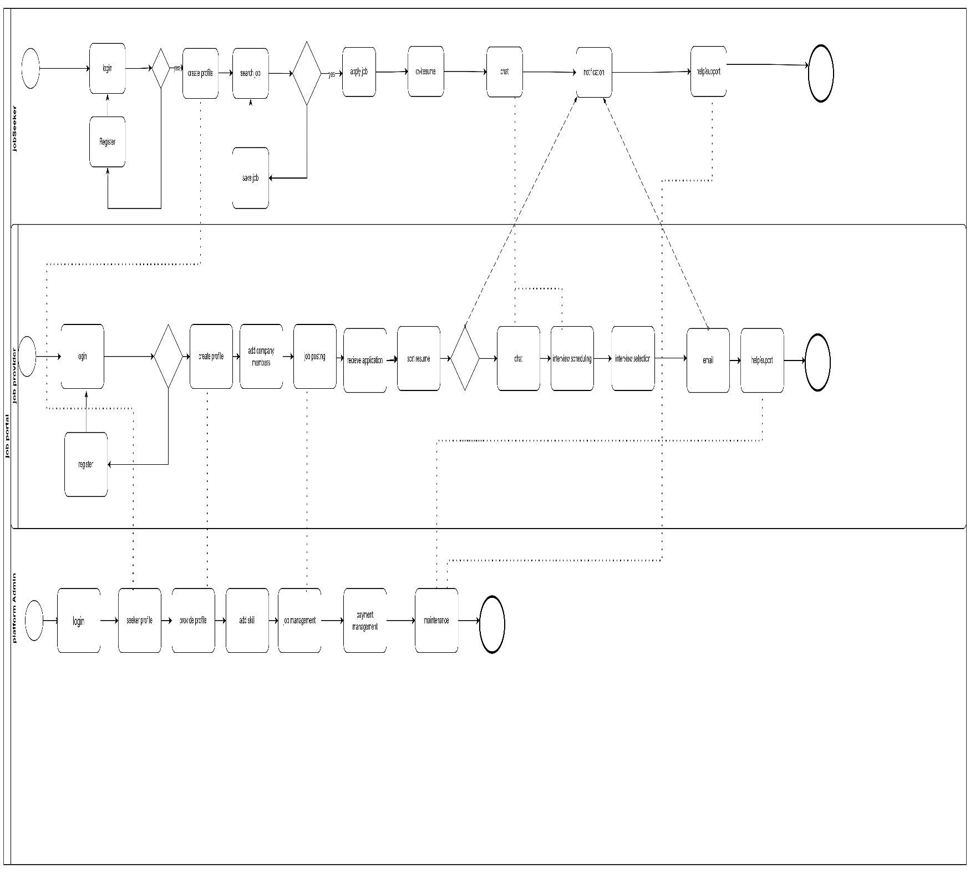**2.3 BUSINESS PROCESS FLOW DIAGRAM**

**3.NON FUNCTIONAL REQUIREMENTS**

While the core features of the Job Portal System define what the platform does, non-functional requirements set the standards for how well it performs. These aspects don’t directly affect the system’s functionality, but they are just as important for delivering a reliable and user-friendly experience. Here are the key non-functional requirements for the system:

3.1 Performance

The system should be responsive and capable of handling multiple users at once without significant delays. Whether it's job seekers browsing listings or employers managing applications, the system should operate smoothly under typical load conditions.

3.2 Reliability

The platform should be consistently available, with minimal downtime. Regular backups and recovery mechanisms must be in place to protect against data loss or system failures. Users should be able to rely on the portal to be available when they need it.

3.3 Usability

The interface should be intuitive and easy to navigate for all users, regardless of their technical background. Clear labels, organized layouts, and helpful prompts will ensure that users can accomplish tasks without confusion or frustration.

3.4 Security

Given that users will share personal and professional information, data security is a top priority. User authentication, encrypted passwords, and role-based access control will be implemented to protect sensitive information.

3.5 Maintainability

The system should be built in a modular, well-documented way that allows future developers or admins to update or fix parts of the system without major complications. This includes clean code structure and consistent naming conventions.

3.6 Scalability

As more users join the platform and activity increases, the system should be able to scale accordingly. This includes both horizontal scaling (adding more servers) and vertical scaling (upgrading resources) to maintain performance.

**4.TECHNICAL REQUIREMENTS**

|  |  |
| --- | --- |
| Processor | AMD RYZEN 5 |
| Hard Disk | 40GB to 80GB |
| Memory | 16GB |
| OS | Windows 11 |
| Front end | HTML, CSS, JavaScript, Bootstrap and Angular |
| Back end | C# |
| Database | MS SQL |
| Framework | ASP.NET core |
| IDE | Visual Studio,visual studio code |

**CONCLUSION**

The Software Requirements Specification (SRS) document for the Job Portal System provides a comprehensive overview of the system's functional and non-functional requirements. It outlines the technical environment, user roles, and operational workflows essential for the successful development and deployment of the platform. The system is designed to bridge the gap between job seekers and employers through an intuitive interface, robust data management, and secure user authentication.With clear definitions of performance criteria, system constraints, and technical requirements—including modern frontend technologies, a scalable backend, and secure database integration—this document ensures a solid foundation for developers, stakeholders, and project managers. Proper adherence to these specifications will result in a reliable, efficient, and user-friendly job portal system that meets business goals and delivers value to its users.